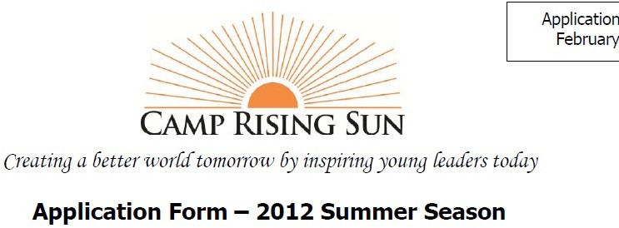

Application Form – 2022 Summer Season
Candidate Information – please write or type clearly

Last name: First name: Gender/Sex: □ Male □ Female

Recent photo that clearly shows your face
Mailing Address:
Street:

City: State: Postal/Zip Code: Country:
Home Phone: Cell Phone: Primary E-Mail Address: Birth Date: Month: Day: Year: Born in: (city and country) School Name: (city and country) Name of Contact Person at School: E-Mail Address of Contact Person:

Family Information
Guardian #1:
Guardian #2:
Name: Name: Relationship to Applicant: Relationship to Applicant: Occupation: Occupation:
Address (if different): Address (if different):
Home Phone: Home Phone: Cell Phone: Cell Phone: Work Phone: Work Phone:
E-mail: E-mail:

Siblings, if any (Please list their names and ages):

How long have you lived in your current community? Where else have you lived? List up to five places you have enjoyed visiting:

City, State, Country | Length of Stay | Purpose of Stay

Are you a native English speaker? □ YES □ NO
If you are not a native English speaker, what is your level of proficiency in spoken English?
□ Fluent □ Proficient □ Intermediate

Academic Interests
Which subjects do you have and which one do you like the most?

In case you have already plans for the future (university, career etc.) please explain them here:

Other Interests
Please, provide as much information as possible about your non-academic life and interests where applicable.
- Social and community work:

- Arts and creative interests (music, painting etc.):

- Sports:

- Responsible functions in your school or somewhere else, like student counsel etc.:

- Other functions, interests or specific things you would like the selection committee to know:

I certify that the information contained in this application is true.

Candidate Signature Print Name Date

I grant permission to my child to apply for the Camp Rising Sun International Leadership Program and attend if selected.

Parent or Legal Guardian Signature Print Name Date

Please do not forget to send the certified copies of your grade marks, the letter of recommendation and your own letter of motivation!

